5Laboratory 05
Jeffrey Daniel Leiva Cascante
Tamara Nicole Rodríguez Luna
Computer engineering department, Tecnológico de Costa Rica
IC4301 – Databases I
Teacher: Msc. Adriana Álvarez Figueroa.
September 30th 2022.

In this document are the evidence of laboratory 05 where you can see the objects created, data inserted, modified, among others.
Evidence:

1. Create a procedure (using OPEN of the cursor) that returns all the phone numbers of a person. The person number must be sent as parameter as well as the phone type and the latter can be null, in which In this case, all the telephones of the person must be displayed. 15pts
TABLE PERSON
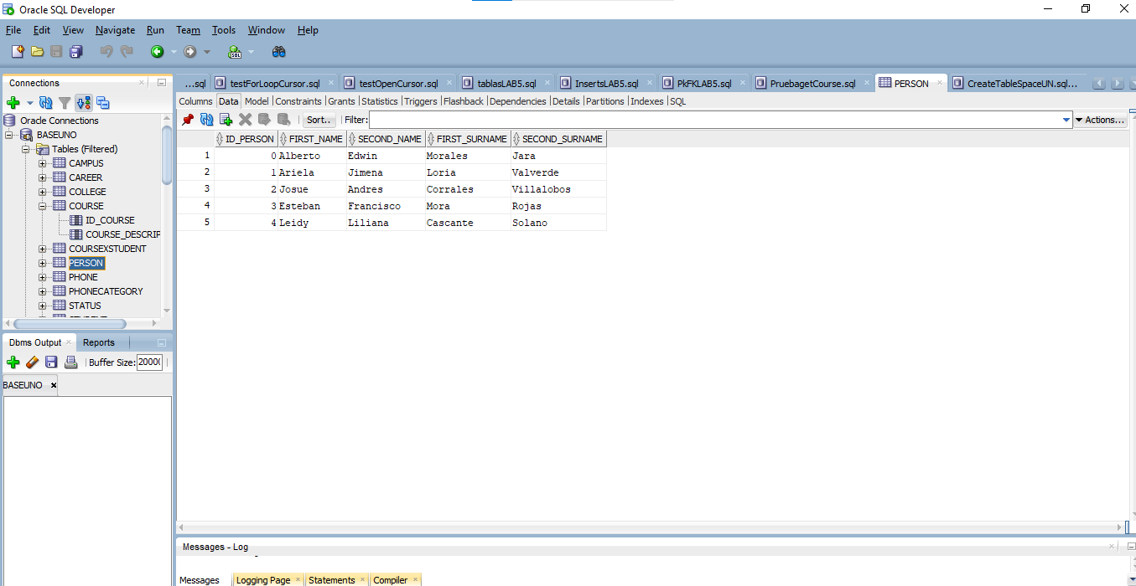
TABLE PHONE
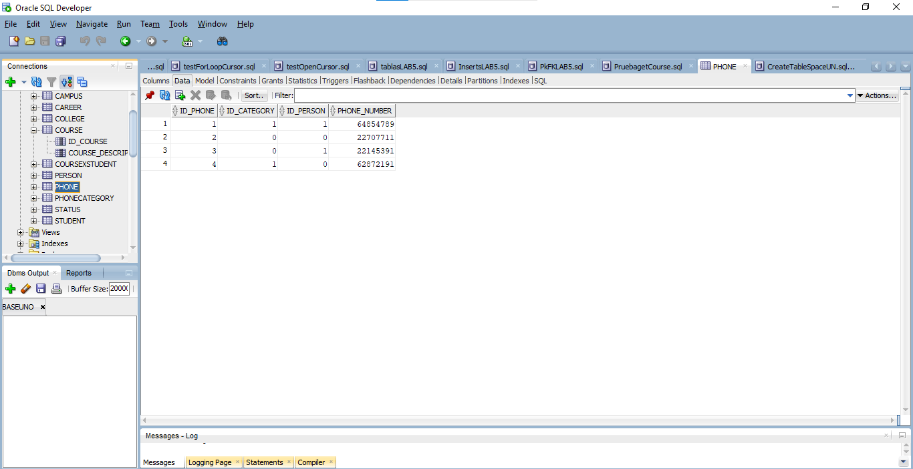

TABLE PHONECATEGORY
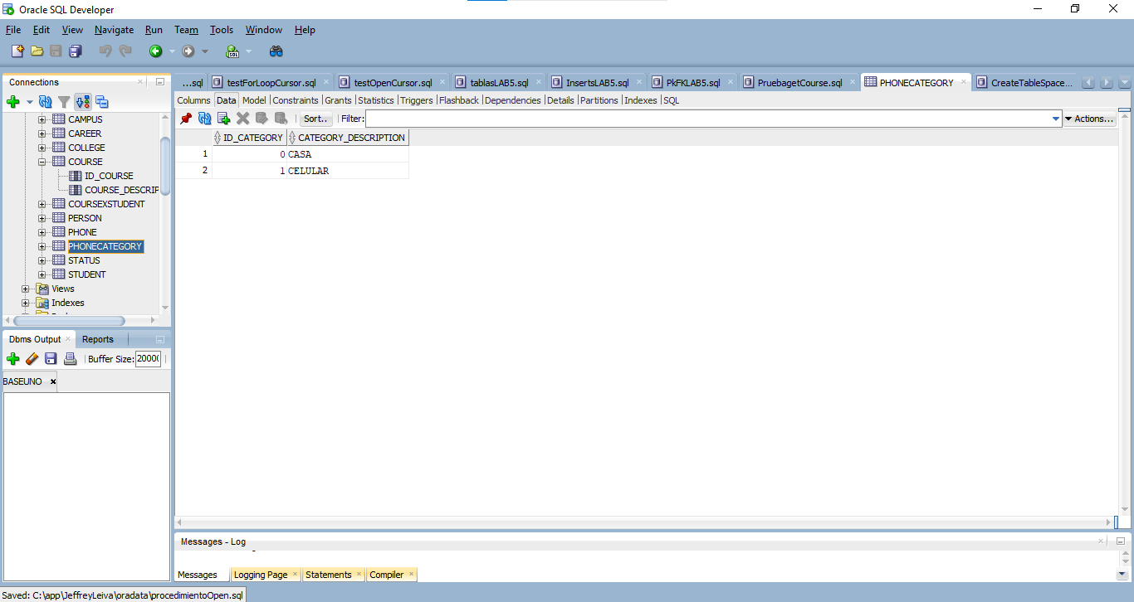
Compilation of getPhones procedure using Open:
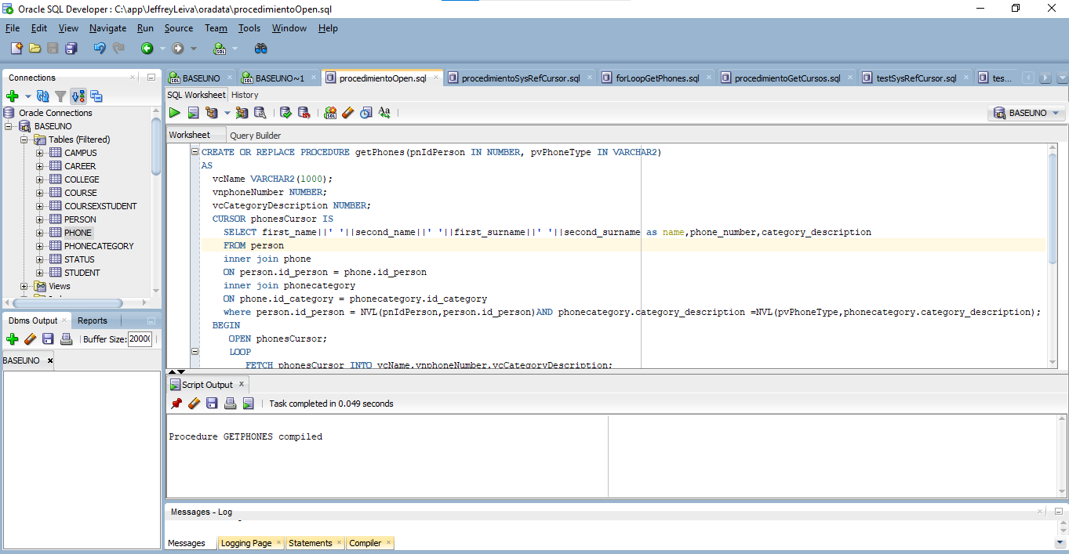

2. Create a test to test the procedure using cursors. 20pts
Next there are the test cases for the previous procedure:
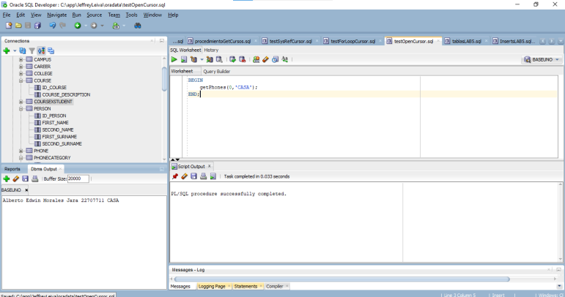
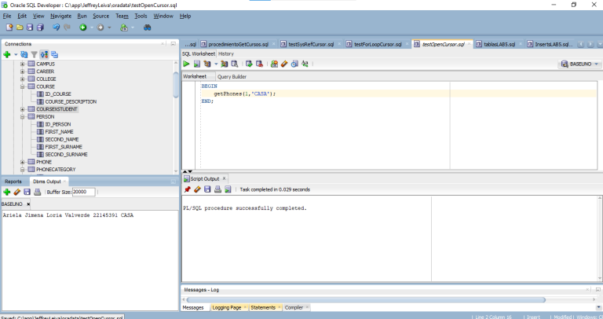

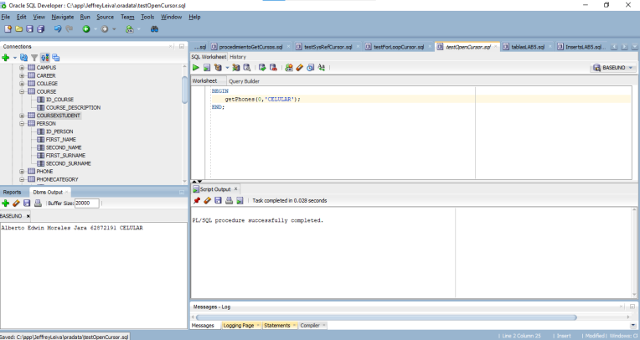

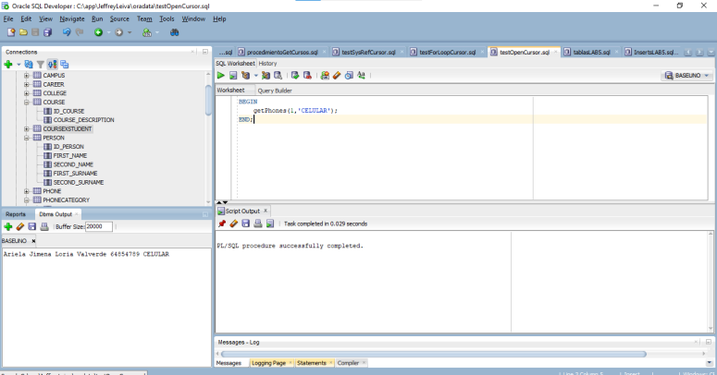

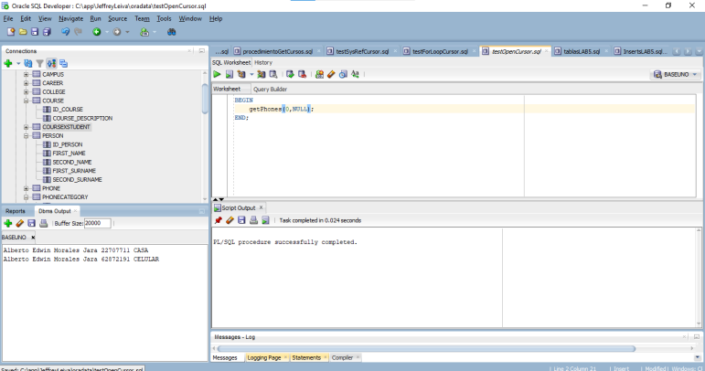
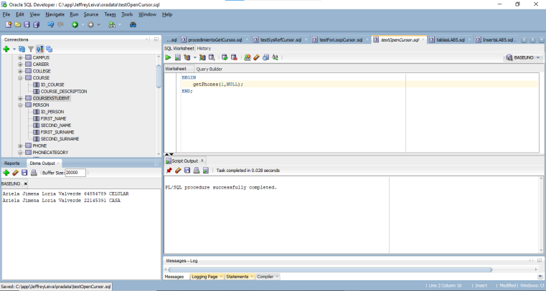

3. What happens when more fields are added in the test fetch? 10pts
The database throws an exception saying that there is a wrong number of values in the INTO list of Fetch Statement.
4. What happens when the fetch of the test failed to obtain fields? 10pts
The database throws an exception saying that there is a wrong number of values in the INTO list of Fetch Statement.
5. What happens when in the test fetch the fields have a different domain from the
what is getting the cursor? 10pts
The procedure compiles and does not throw any exceptions but when you call it from the test query it throws an exception that says there are numeric or value errors.
6. Modify the cursor to use the code with LOOP. 10pts
Compilation of the getPhones Procedure using for loop:
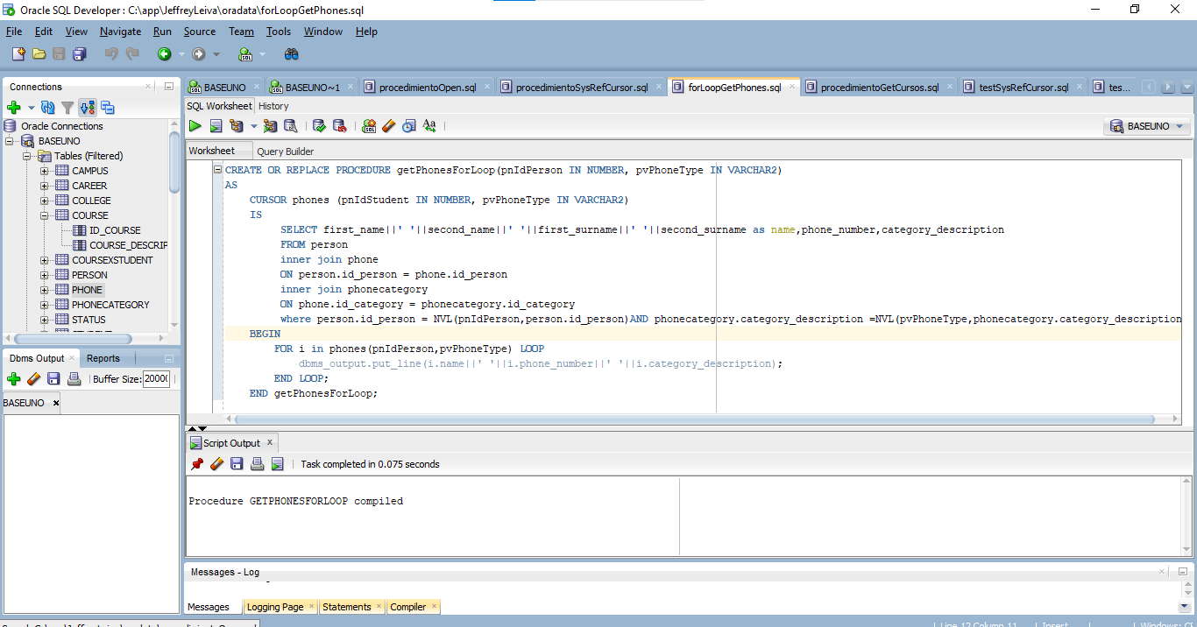

Next there are various test cases for this point.
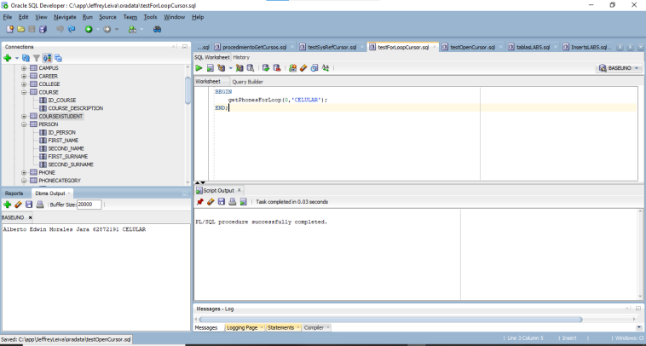
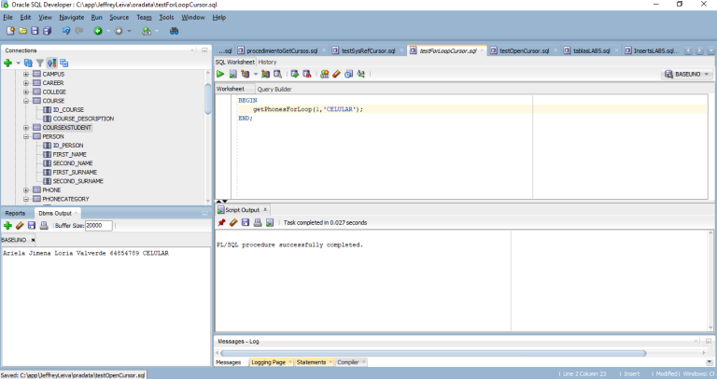
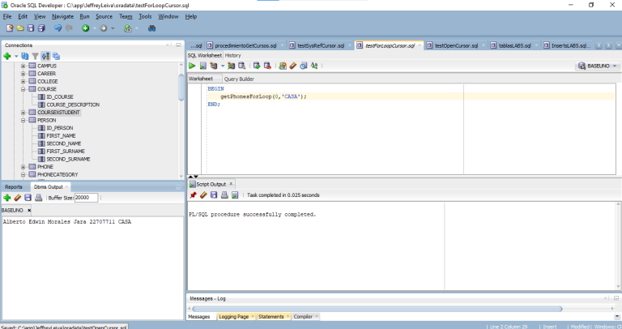
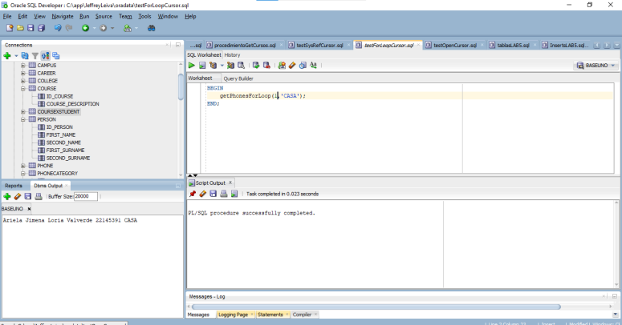
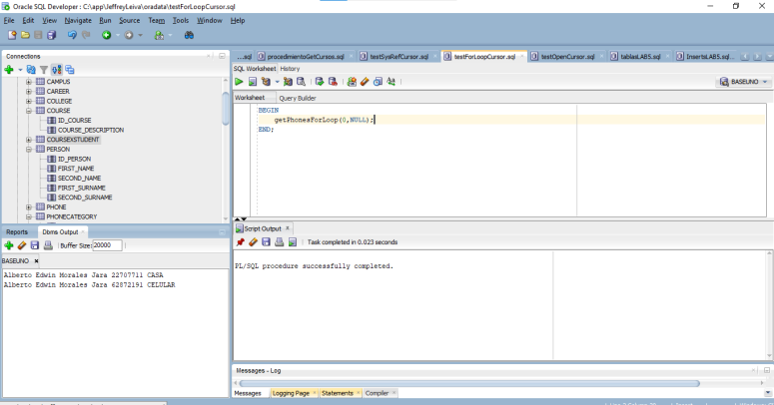
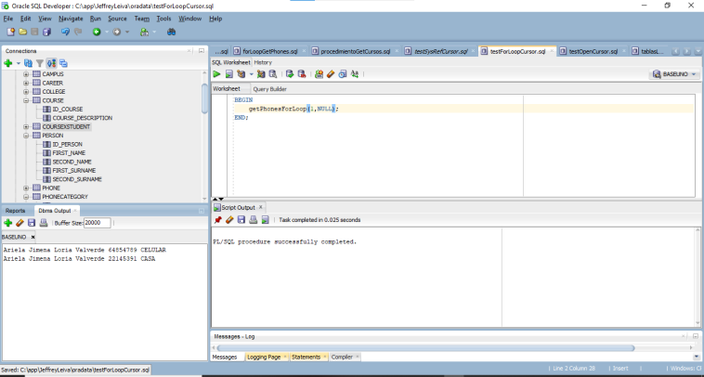

7. Modify the cursor to use the code from SYS_REFCURSOR.10pts

Compilation for the getPhones procedure using sys_refcursor:

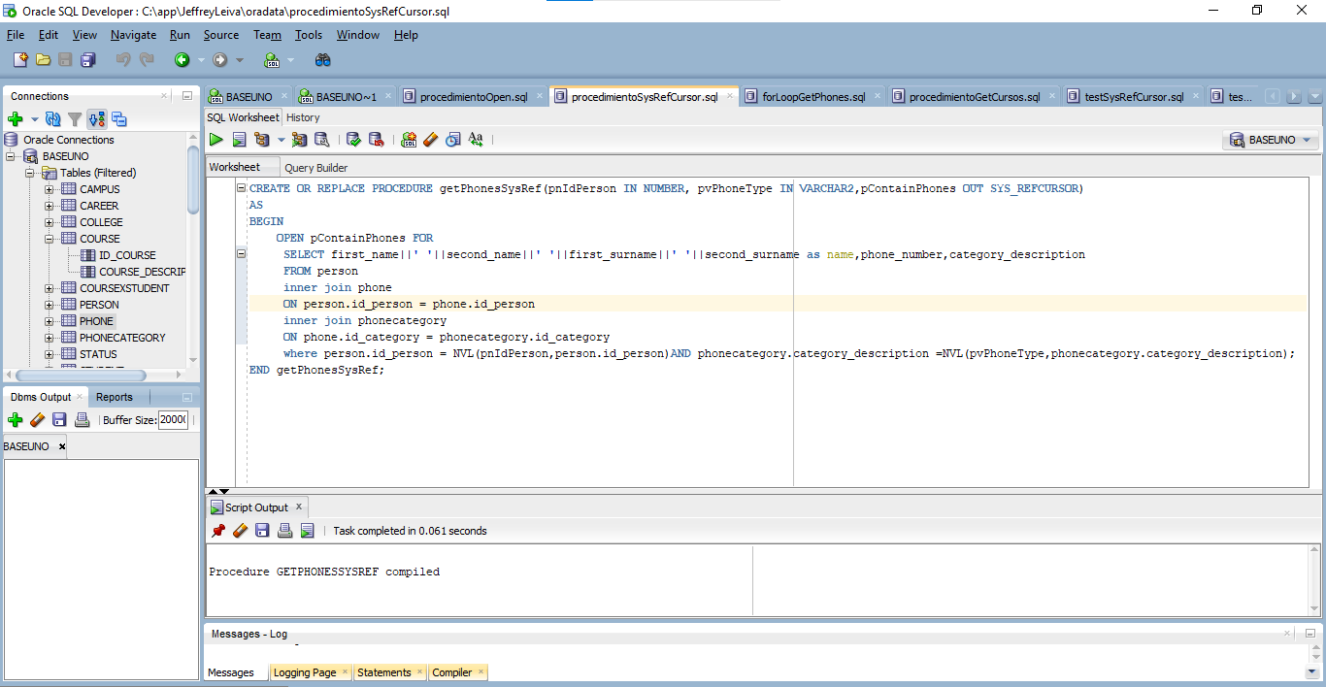
Next there are some test cases
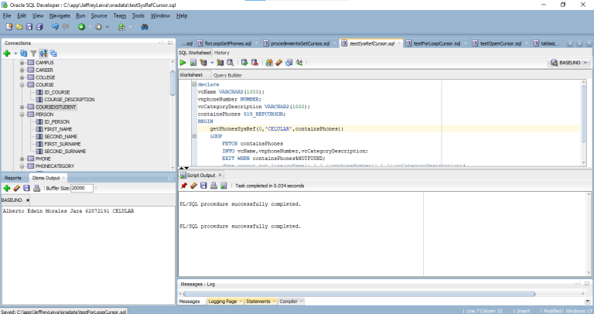
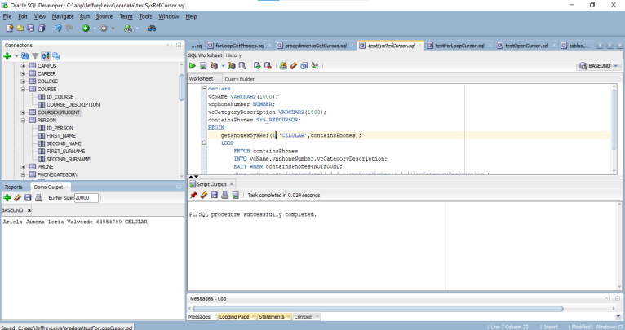
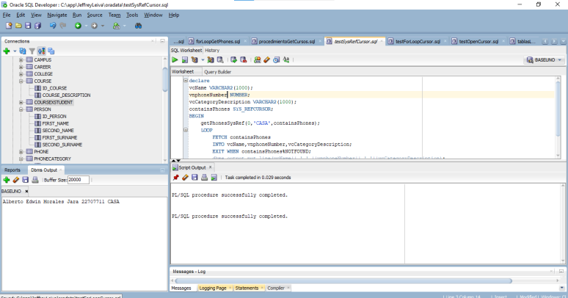
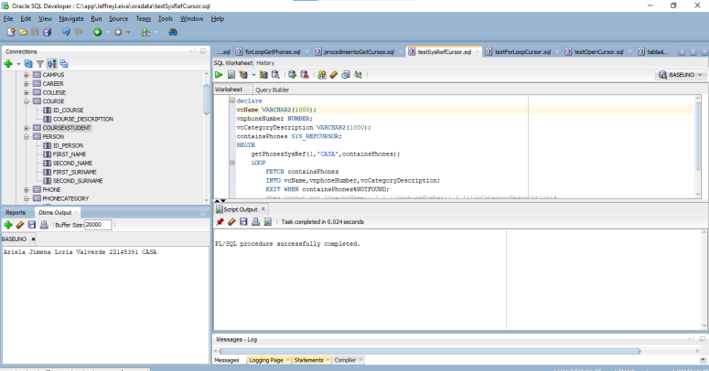
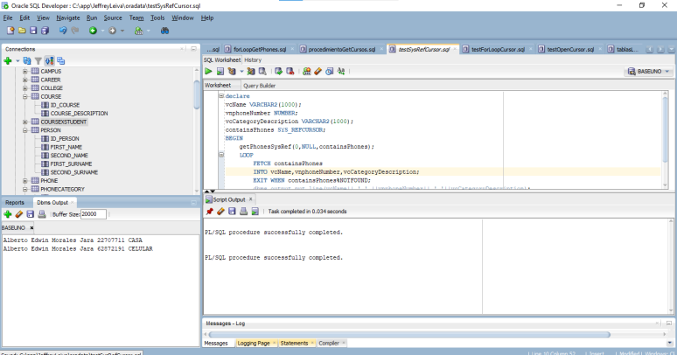

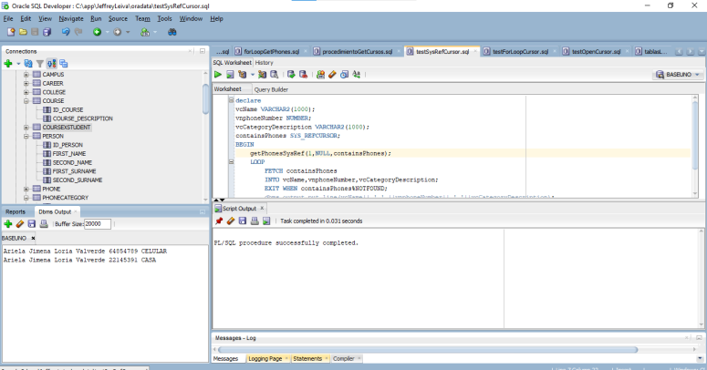
8. Create the UN schema and create the student, courses and their associations tables. Create a cursor getCursos that returns the courses of a student from the student_id and the status of the course (either approved, failed, pending) where this last parameter can be null in which case it must return all the student's courses and the status of it. 15pt
Creation of UN tablespace:

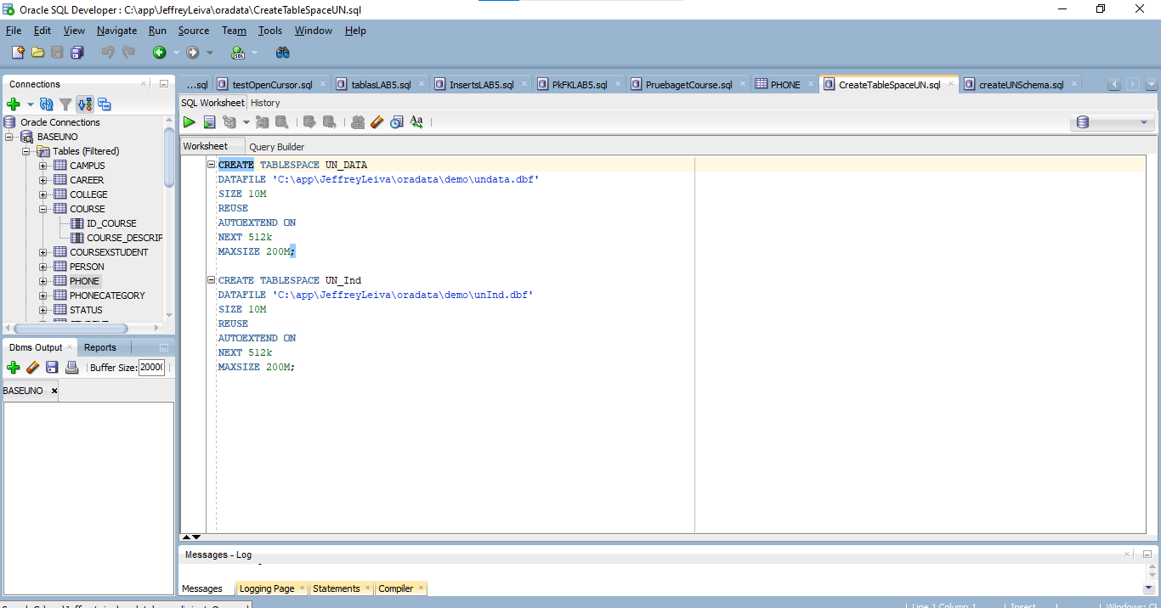
Creation of UN schema
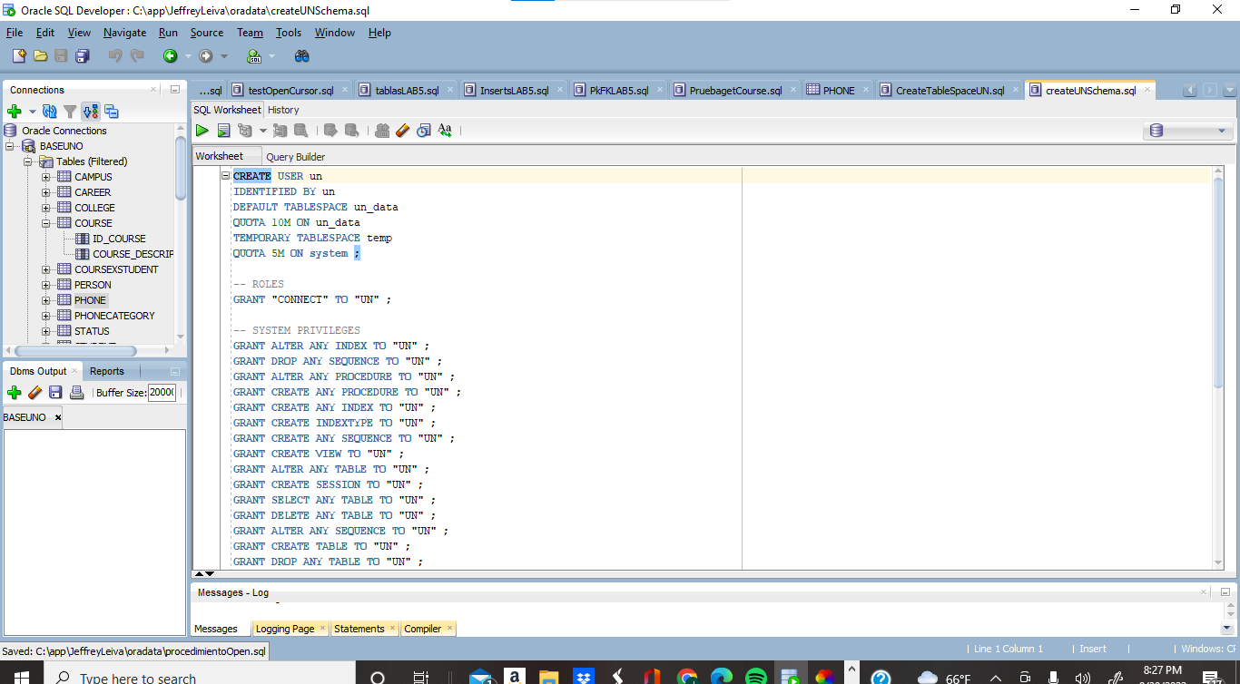

TABLE COURSE

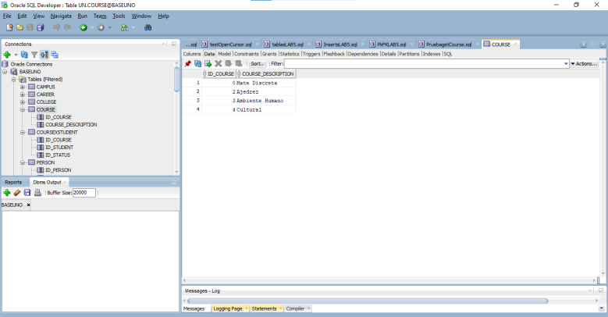

TABLE COURSEXSTUDENT

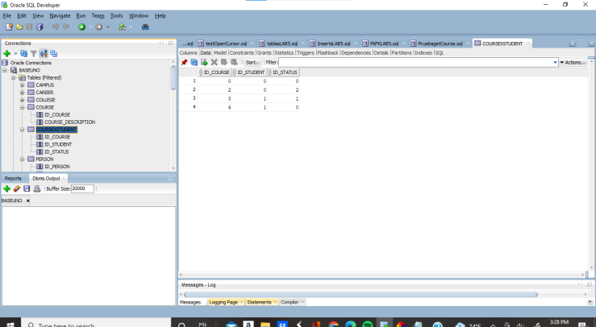

TABLE STUDENT

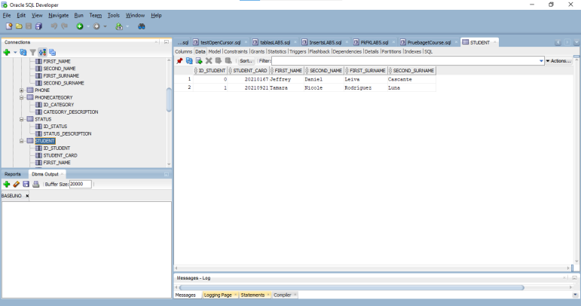

TABLE STATUS

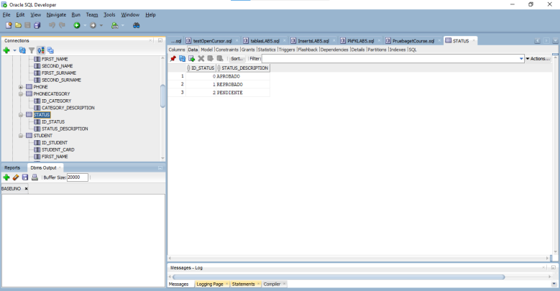

PROCEDURE GETCOURSE
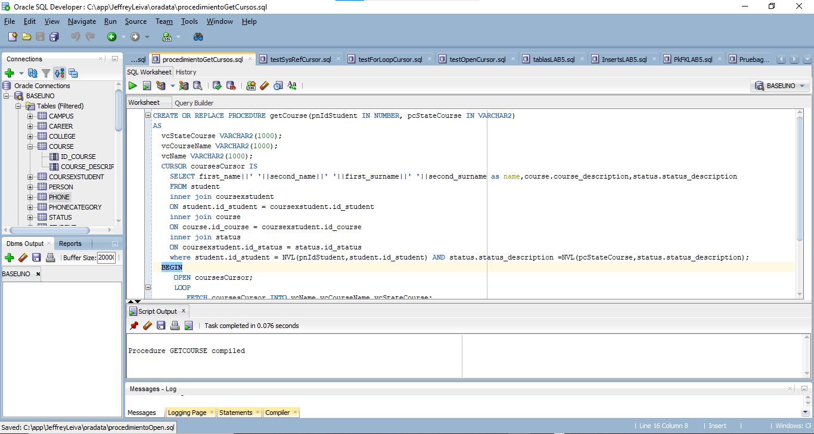

Next there are some test casese for the procedure.
